**API Tool**

**Problem Statement:**

Whenever we have an issue with Application like Service Down, we tend to open up SOAP and view the response and send an email to the respective teams if service is down. This takes a lot of time since we have to make sure which services to be checked for the validation and provide proper Request.

**Solution:**

To handle this, a Java Utility created where the API Rest services are already in place, on selecting the required API and giving the necessary details and upon execution, the response will be displayed and user can choose whether to Draft that into mail or not so as to send to the respective team for Analysis.

**Steps to use this Tool:**

1. Open the API Utility, **Select the API** you want to check and Click on **GO** Button

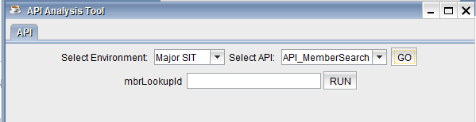

1. The input you need to give for the API response will be displayed. Please enter the necessary details and click on **RUN** Button.

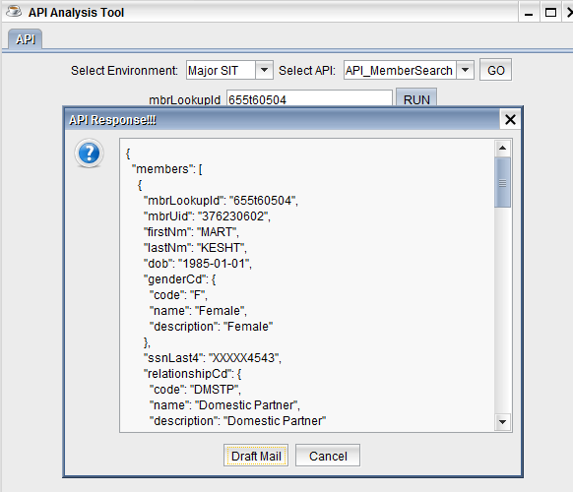

1. API Response is displayed, if required can click on **Draft mail** Button, to send the mail

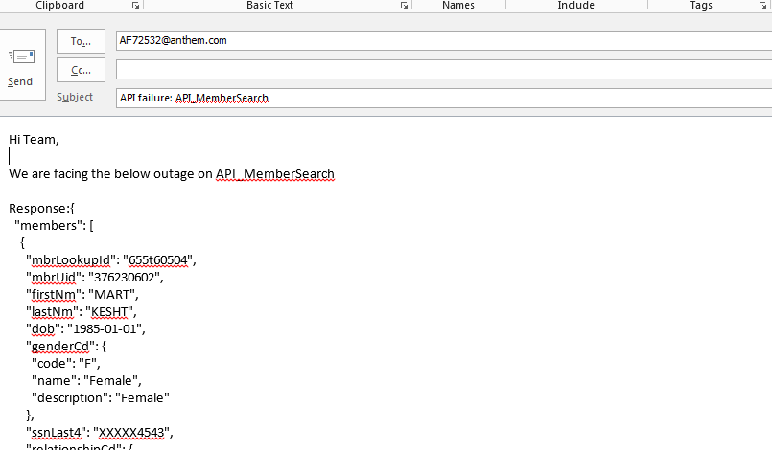

1. Email is Drafted Successfully with the response. You can add the recipient’s you want to and send out an email
2. In case of **Outage,** Response/Error of the API will be displayed

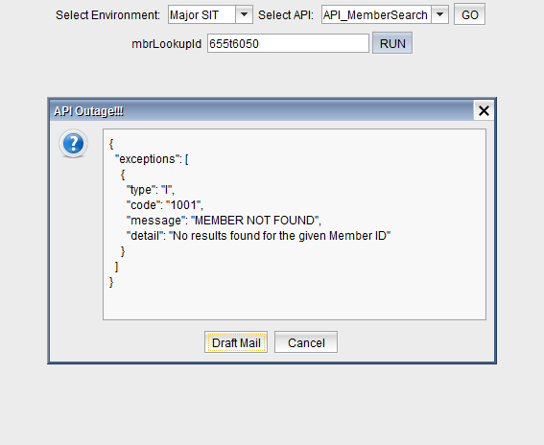

1. By clicking on the **Draft email** button your email is ready to send. Make changes if necessary and send to the corresponding team.

**Add New API to the tool:**

1. In the **API.txt** file, add the API in following Format

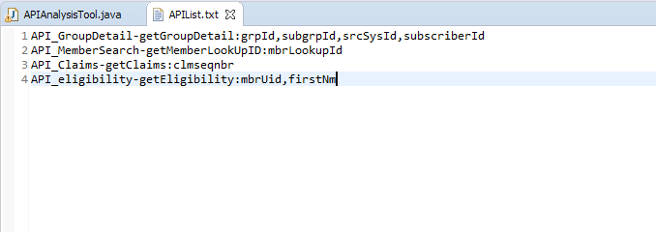For Example: API_GroupDetail-getGroupDetail:grpId,subgrpId,susbscriberId

1. API_GroupDetail 🡪ClassName of API
2. getGroupDetails 🡪 MethodName in the Class
3. grpId,subgrpId,susbscriberId 🡪 Attributes to that API

Below is the sample API Class File, which is to be created.

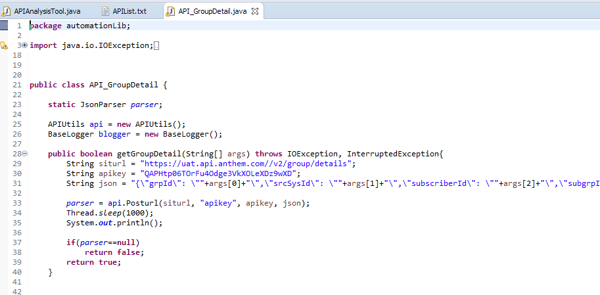

On completion of the above steps, **API is added to the Tool Successfully!!!**